|  |  |
| --- | --- |
| Bus Communication with External Memory.  3rd October 2019.  Prof Randall Brouwer | Daniel Ackuaku |

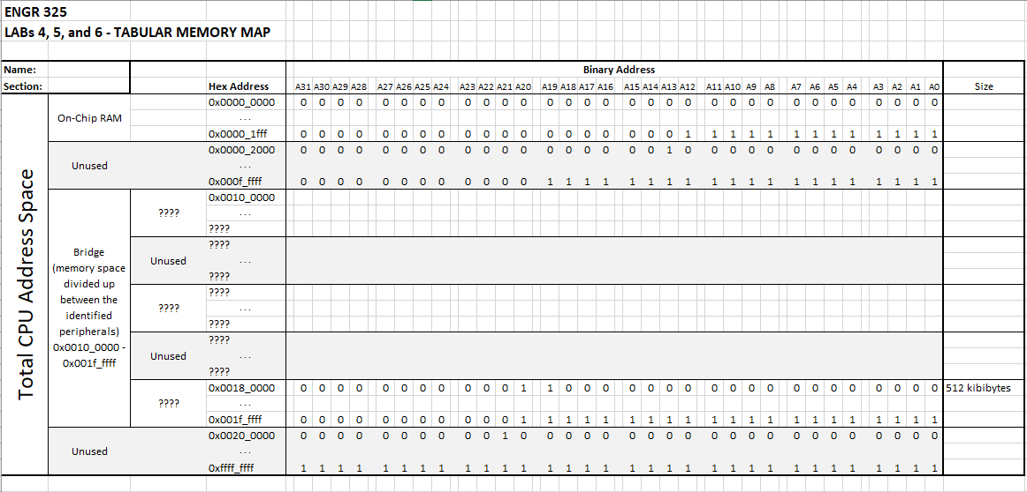

Figure An image of the Lab456AddressMap.xlsx file

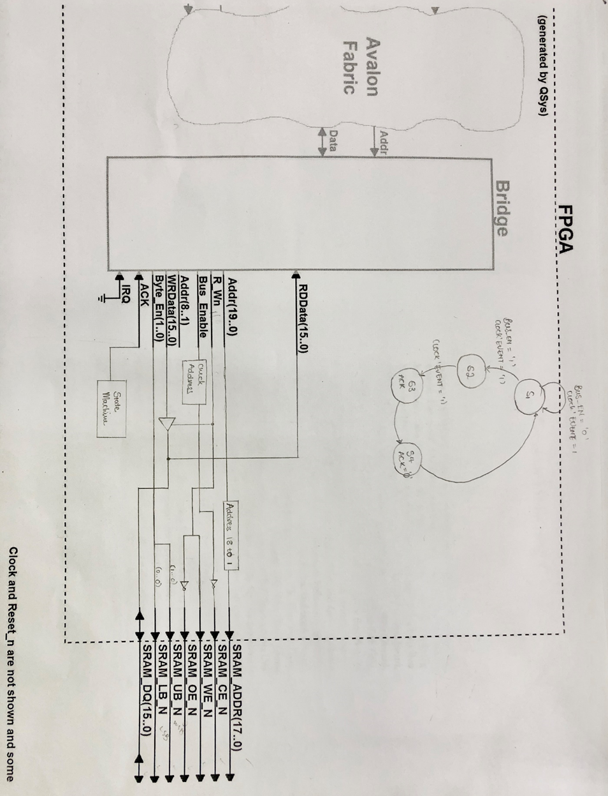

Figure A copy of the block diagram and state diagram.

VHDL CODE for Part A

LIBRARY ieee;

USE ieee.std_logic_1164.ALL;

USE ieee.std_logic_unsigned.ALL;

ENTITY Lab4 IS

PORT (

CLOCK_50 : IN STD_LOGIC;

KEY : IN STD_LOGIC_VECTOR(0 DOWNTO 0);

SRAM_ADDR : OUT STD_LOGIC_VECTOR(17 DOWNTO 0);

SRAM_DQ : INOUT STD_LOGIC_VECTOR(15 DOWNTO 0);

SRAM_WE_N : OUT STD_LOGIC;

SRAM_OE_N : OUT STD_LOGIC;

SRAM_UB_N : OUT STD_LOGIC;

SRAM_LB_N : OUT STD_LOGIC;

SRAM_CE_N : OUT STD_LOGIC;

ACK : OUT STD_LOGIC;

BUS_EN : OUT STD_LOGIC

);

END Lab4;

ARCHITECTURE Lab4_rtl OF Lab4 IS

-------------------------------------------------------------------------

-- Signal definitions

-------------------------------------------------------------------------

type State_type IS (S1,S2,S3,S4);

signal y_present, y_next : State_type;

Signal ACK_sig : STD_LOGIC;

Signal IRQ_sig : STD_LOGIC;

Signal Bridge_address_sig : STD_LOGIC_VECTOR(19 DOWNTO 0);

Signal Bridge_bus_enable_sig : STD_LOGIC;

Signal Bridge_byte_enable_sig : STD_LOGIC_VECTOR(1 DOWNTO 0);

Signal Bridge_rw_sig : STD_LOGIC;

Signal Bridge_write_data_sig : STD_LOGIC_VECTOR(15 DOWNTO 0);

Signal Bridge_read_data_sig : STD_LOGIC_VECTOR(15 DOWNTO 0);

component nios_system is

port (

clk_clk : in std_logic := 'X'; -- clk

reset_reset_n : in std_logic := 'X'; -- reset_n

bridge_acknowledge : in std_logic := 'X'; -- acknowledge

bridge_irq : in std_logic := 'X'; -- irq

bridge_address : out std_logic_vector(19 downto 0); -- address

bridge_bus_enable : out std_logic; -- bus_enable

bridge_byte_enable : out std_logic_vector(1 downto 0); -- byte_enable

bridge_rw : out std_logic; -- rw

bridge_write_data : out std_logic_vector(15 downto 0); -- write_data

bridge_read_data : in std_logic_vector(15 downto 0) := (others => 'X') -- read_data

);

end component nios_system;

BEGIN

-------------------------------------------------------------------------

-- Signal assigingments

-------------------------------------------------------------------------

SRAM_ADDR <= Bridge_address_sig(18 downto 1);

SRAM_WE_N <= Bridge_rw_sig;

SRAM_OE_N <= not Bridge_rw_sig;

SRAM_UB_N <= not Bridge_byte_enable_sig(1);

SRAM_LB_N <= not Bridge_byte_enable_sig(0);

SRAM_CE_N <= not (Bridge_bus_enable_sig AND Bridge_address_sig(19));

SRAM_DQ <= Bridge_write_data_sig when Bridge_rw_sig = '0'

else (others =>'Z'); --"ZZZZZZZZZZZZZZZZ";

Bridge_read_data_sig <= SRAM_DQ;

u0 : component nios_system

port map (

clk_clk => CLOCK_50, -- clk.clk

reset_reset_n => KEY(0), -- reset.reset_n

bridge_acknowledge => ACK_sig, -- bridge.acknowledge

bridge_irq => IRQ_sig, -- .irq

bridge_address => Bridge_address_sig, -- .address

bridge_bus_enable => Bridge_bus_enable_sig, -- .bus_enable

bridge_byte_enable => Bridge_byte_enable_sig, -- .byte_enable

bridge_rw => Bridge_rw_sig, -- .rw

bridge_write_data => Bridge_write_data_sig, -- .write_data

bridge_read_data => Bridge_read_data_sig -- .read_data

);

-----------------------------------------------------------------------------

-- State machine process for the acknowledge

-----------------------------------------------------------------------------

process (Bridge_bus_enable_sig, y_present) is

BEGIN

CASE y_present IS

WHEN S1 => --State1

if (Bridge_bus_enable_sig = '1') then

ACK_sig <= '0';

y_next <= S2;

else

ACK_sig <= '0';

y_next <= S1;

end if;

WHEN S2 => --State2

ACK_sig <= '0';

y_next <= S3;

WHEN S3 => --State3

ACK_sig <= '1';

y_next <= S4;

WHEN S4 => --State4

ACK_sig <= '0';

y_next <= S1;

END CASE;

end process;

process (CLOCK_50, KEY(0))

BEGIN

if (KEY(0) = '0') then

y_present <= S1;

elsif (CLOCK_50' EVENT AND CLOCK_50 = '1') then

y_present <= y_next;

end if;

end process;

IRQ_sig <= '0';

ACK <= ACK_sig;

BUS_EN <= Bridge_bus_enable_sig;

END Lab4_rtl;

------------------------------------------------------------------------------------------------------------------------------------------

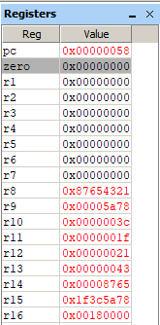

Figure A diagram of the registers for the assembly code SRAM instructions.

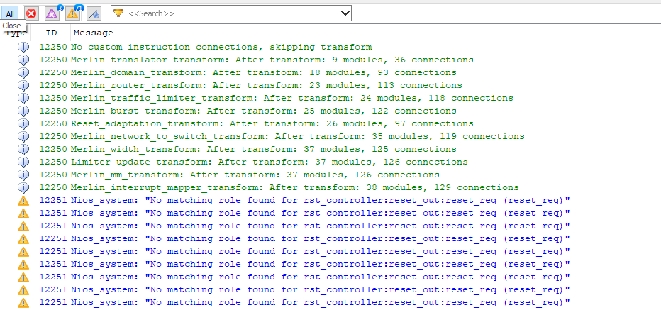

Figure . Quartus warnings 1.

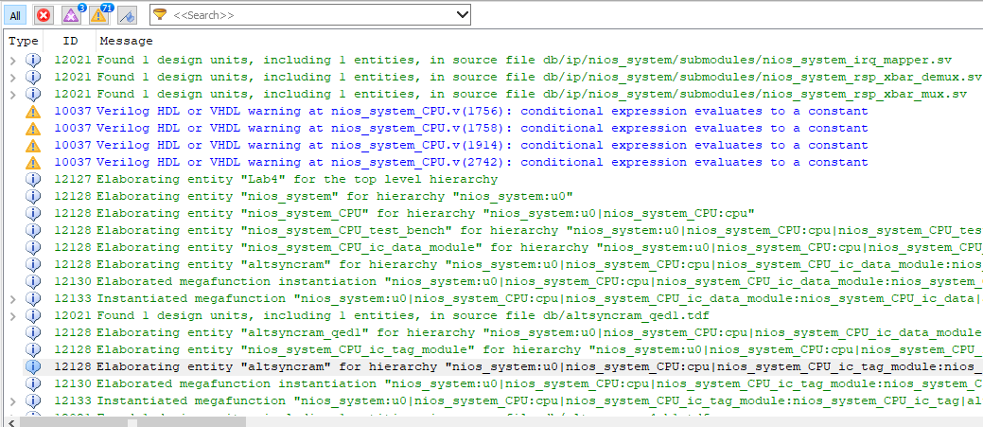

Figure Quartus warnings 2.

Part C

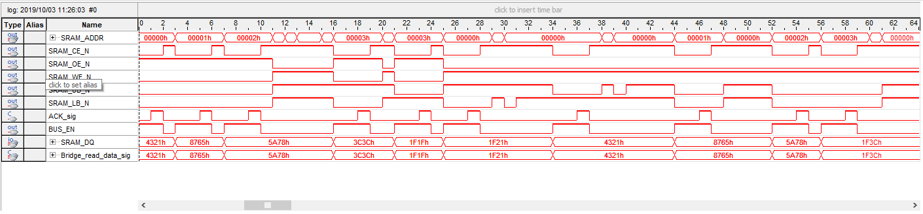

Figure Signal tap of the assembly version.

Part E

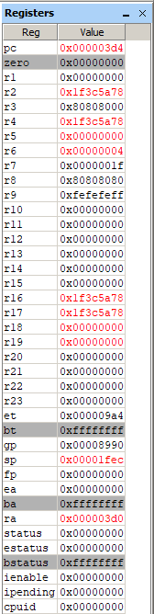 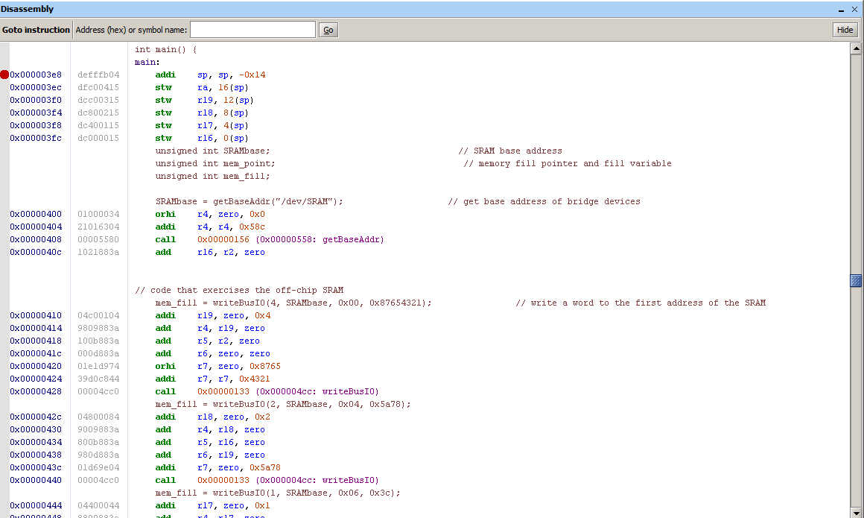

Figure 7. Register values of the c code. Figure 8. Disassembly of the c code.

